HYPEREMESIS GRAVIDARUM
Nausea and vomiting in pregnancy are extremely common; 70–80% of women experience these symptoms early in their pregnancy. Mild to moderate nausea and vomiting are especially common in pregnant women until approximately 16 weeks’ gestation.
Hyperemesis gravidarum (HEG) is defined as unexplained intractable nausea, retching, or vomiting beginning in the first trimester, resulting in dehydration, ketonuria, and typically a weight loss of more than 5% of pre-pregnancy weight. Severe HEG requiring hospital admission occurs in 0.3-2% of pregnancies.
Etiology
The pathogenesis is largely unknown, with possible contributing factors being increased levels of human chorionic gonadotropin (hCG), estradiol, and possible progesterone. It is more common among younger mothers and those with a history of motion sickness, migraines, and nausea and vomiting associated with oral contraceptives. It is more commonly seen in women carrying multiple gestations, and patients with siblings or a mother with HEG are more likely to be affected.
Other factors that increase the risk for admission include hyperthyroidism, previous or concurrent molar pregnancy, diabetes, gastrointestinal illnesses, some restrictive diets, and asthma and other allergic disorders. An association of Helicobacter pylori infection has been proposed, but evidence is not conclusive. Chronic marijuana use may cause the similar cannabinoid hyperemesis syndrome. And for unknown reasons—perhaps estrogen related—a female fetus increases the risk by 1.5-fold.
Symptoms & Signs
HEG is associated with severe nausea and vomiting that may result in dehydration, weight loss, and frequently social isolation and negative impacts on relationships with family and friends. Patients with HEG, rather than nausea and vomiting of pregnancy, tend to have an earlier onset and longer duration. Excess salivation (ptyalism) may also be seen in a subset of women with HEG.
On examination features of dehydration and ketoacidosis may be present such as: dry coated tongue, sunken eyes, acetone smell in breath, tachycardia, hypotension, rise in temperature may be noted, jaundice is a late feature.
Complications
Maternal complications of HEG can include Wernicke’s encephalopathy (due to thiamine deficiency), acute tubular necrosis/acute kidney injury (due to severe dehydration), central pontine myelinolysis, Mallory-Weiss tear of the esophagus, pneumomediastinum, and splenic avulsion. Additionally, significant psychological burden of the disease has been reported, with depression, anxiety, and lost work frequently seen among those with persistent or severe HEG. Fortunately, no clear fetal complications have been associated with HEG. Fetal risks may
be due to low birth weight.
Diagnosis
The pregnancy is to be confirmed first. Suppressed thyroid-stimulating hormone/elevated free thyroxine and elevated liver enzymes, bilirubin, amylase, and lipase may all be noted in patients with severe nausea and vomiting; these are transiently abnormal and resolve with improvement of HEG. Other initial laboratory studies in the evaluation of women with HEG are:
- Urinalysis for ketones and specific gravity
- Serum levels of electrolytes and ketones
- Urine culture
- Calcium level
- Hematocrit level
Differential Diagnoses
The differential diagnosis for late (onset after 9 weeks’ gestation) HEG should include gastroenteritis, gastroparesis, biliary tract disease, hepatitis, acute febrile infection, peptic ulcer disease, pancreatitis, appendicitis, pyelonephritis, ovarian torsion, diabetic ketoacidosis, migraines, drug toxicity or withdrawal, psychological conditions, acute fatty liver of pregnancy, and preeclampsia.
Management
Initial management of pregnant women with HEG should be conservative and may include reassurance, dietary recommendations and support. Dietary modifications in patients with HEG or morning sickness may include the following:
- Eat when hungry, regardless of normal meal times
- Eat frequent small meals
- Avoid fatty and spicy foods and emetogenic foods or smells. Increase intake of bland or dry foods.
- Eliminate pills with iron
- High protein snacks are helpful
- Crackers in the morning may be helpful
- Other suggested foods include herbal teas containing peppermint or ginger, other ginger-containing beverages, broth, unbuttered toast, gelatin or frozen desserts.
If pharmacologic therapy is necessary, treatment is given using the algorithm below that balances safety and efficacy:
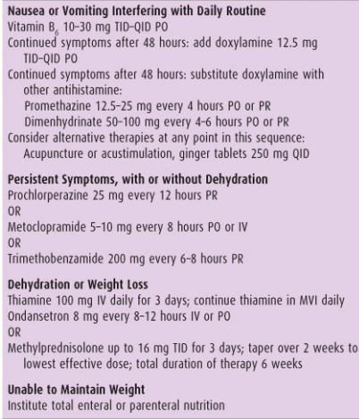
If medications and outpatient hydration fail or if severe electrolyte disturbance persist, inpatient admission for IV hydration may be necessary. In some refractory severe cases of HEG, if maternal survival is threatened, or if HEG is causing severe physical and psychological burden, termination of pregnancy should be considered.
Prognosis
More than 50% of women have resolution of symptoms by 16 weeks of gestational age and 80% by 20 weeks. However, approximately 10% will be affected to some degree with severe nausea and vomiting for the duration of the pregnancy. HEG has been shown to recur in up to 80% of subsequent pregnancies, although earlier aggressive medical therapy prior to significant symptoms has been demonstrated to reduce both the severity and recurrence rate overall in future pregnancies.

